**Park Quadrant door handle tightening instructions**

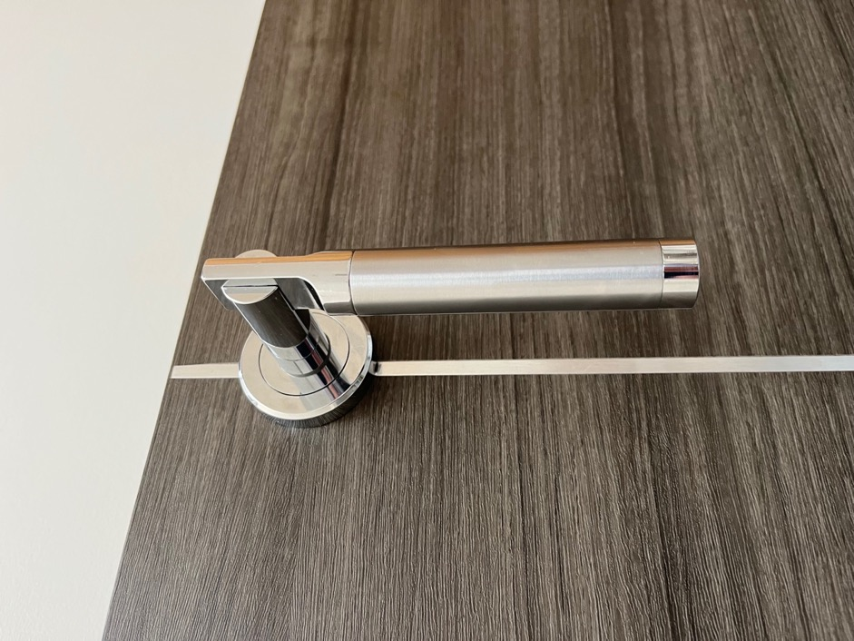

1. Unscrew grub screw in each handle with an allen key

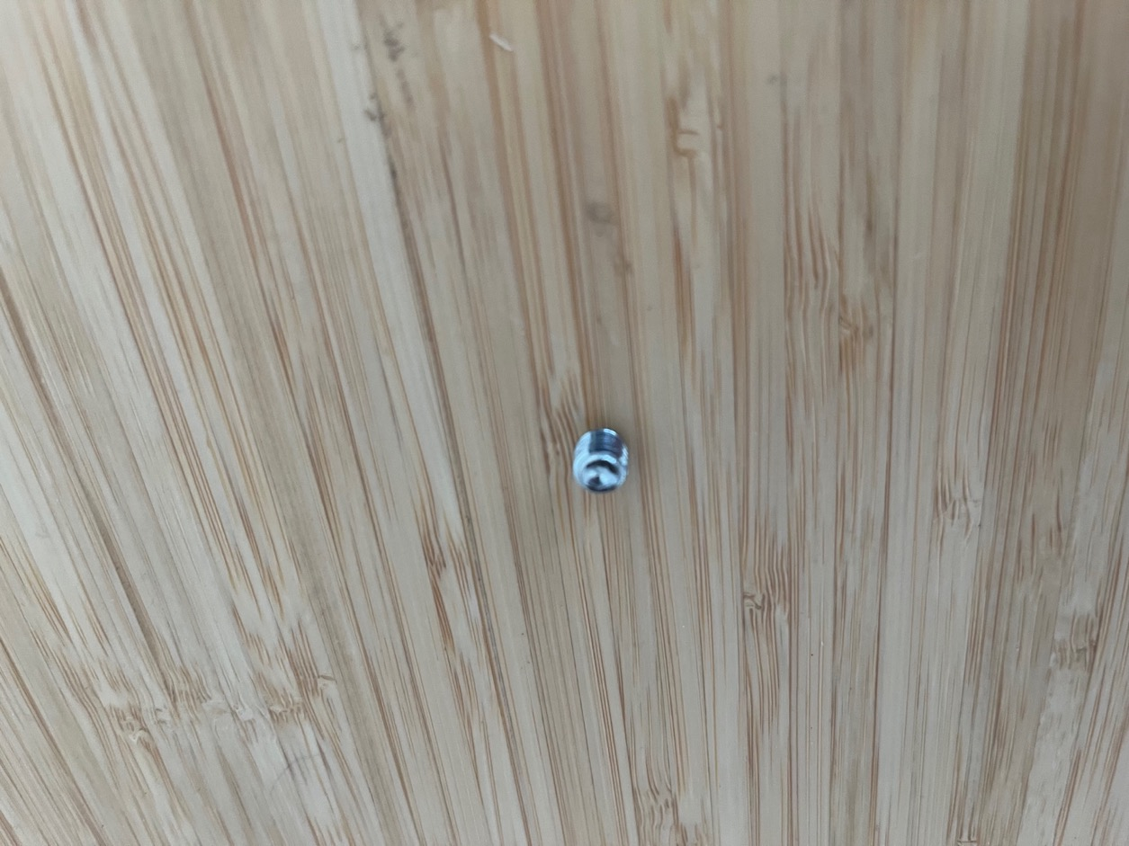

1. Unscrew the rings covering the base of each handle by turning

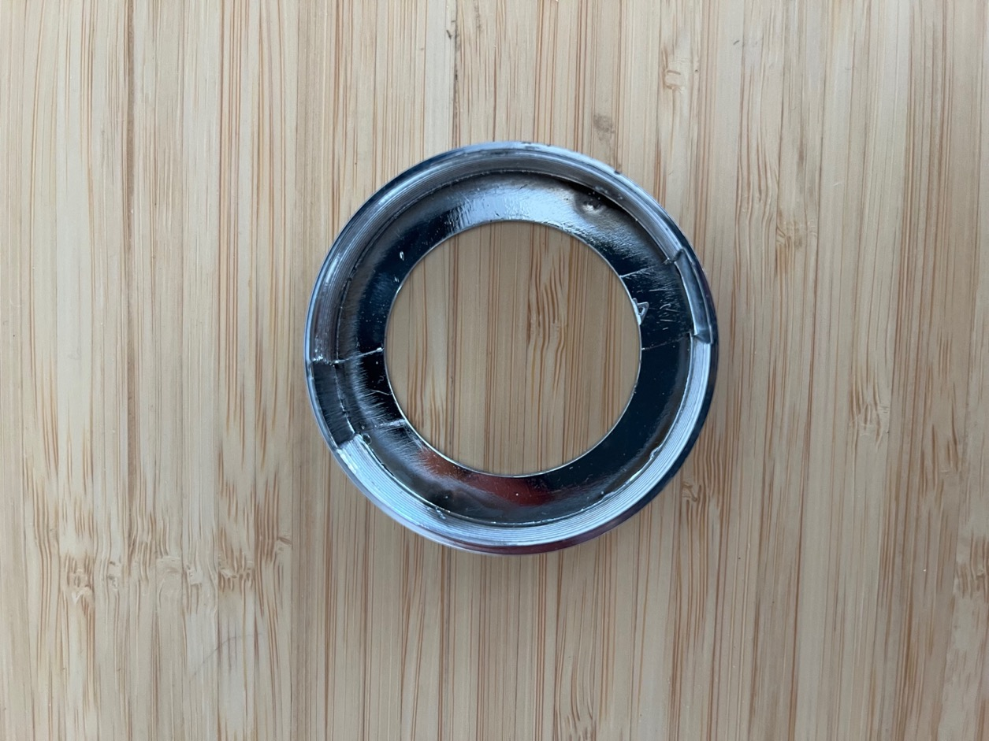

1. Unscrew the two screws attaching bolts through door with flat headed screwdriver

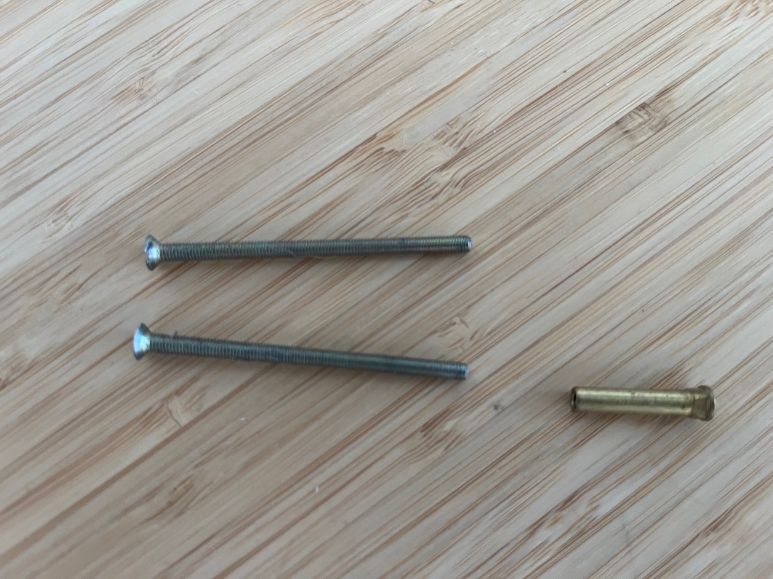

1. Unscrew the small screw at the top, holding on the handle at side to be tightened

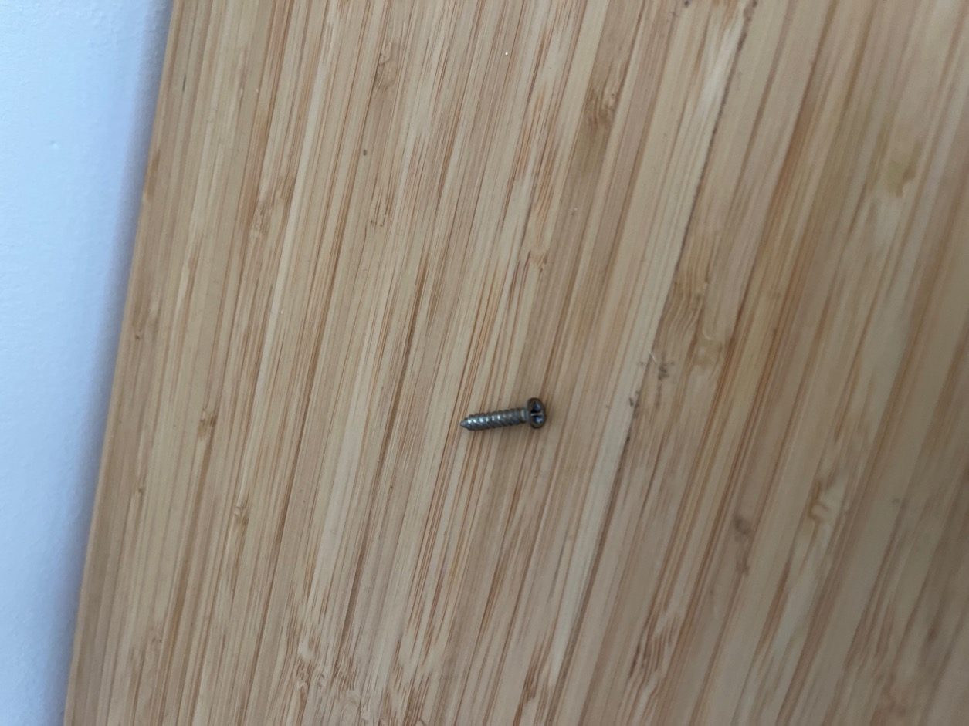

1. Remove the handle to be tightened
2. Tighten the handle using an allen key placed down the centre

1. Replace parts in reverse order from steps 6 to 1 above.